LTspice Analysis of a Step-Down Switching Regulator

ECEN 390: Electromagnetics
Author: Seth Ricks
12/8/2025

My Electromagnetics project was to design and simulate a DC power supply. This was in the form of a Step-Down Switching Regulator, using LTspice. In this report, I will discuss the functions of the LT3971A IC, the switching frequency, the output voltage, a start-up simulation, the efficiency of the circuit, and a steady-state simulation.
I utilized LT3971A IC step-down switching regulator to convert a 14 to 24V input from a theoretical solar panel to an output of 3.0 to 10.0 V range, of which I chose 5.0 V. The maximum DC output current is 1A, per given by the specifications. The efficiency of the power converter at $V_{in}=18V$ is $89.4\%.$
The LT3971A IC is a switching-regulator integrated circuit. It takes a relatively high input voltage, in this case from a solar panel, and converts it to a lower output voltage. I was tasked to choose a 49.9 k$Ω R_{T}$ value, which is associated with an 800 kHz (0.8 MHz) frequency. This can be seen in Table 1, which is from the LT3971A IC data sheet.
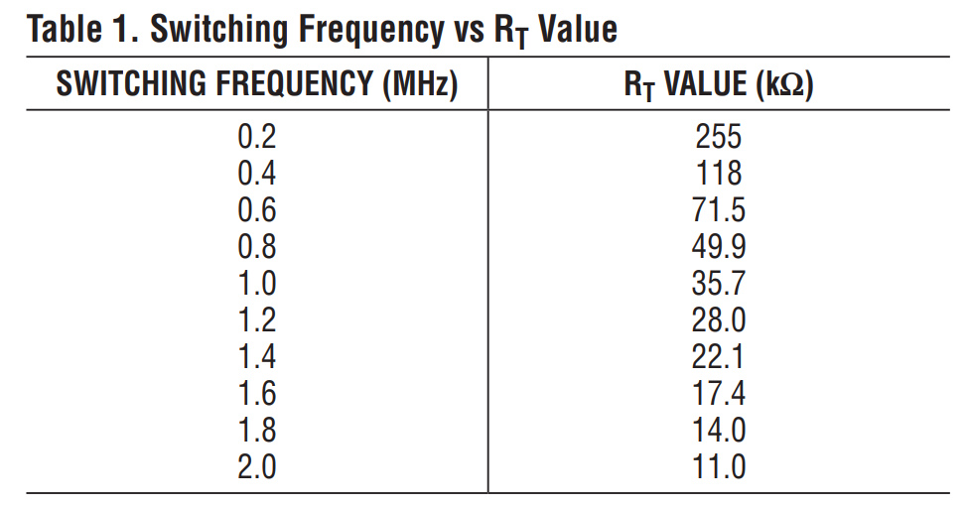
Table 1: Switching Frequency vs $R_{T}$Value
As previously mentioned, I was tasked with setting the output voltage of this regulator, within the range of 3.0 to 10.0 V, of which I chose 5V. With this choice, I had to derive the values for other components in the regulator, to meet the chosen output voltage. These values can be seen in Table 2 below.

V_{out} Chosen | 5.0 V
R2 | 1.02M$Ω$
R1 | $$3.24MΩ$$
R1 + R2 | $$4.26MΩ$$
L1 Calculated | $$6.875μH$$
Part number, inductance value and peak current of chosen inductor L1 | SRR7045-6R8M, 6.8$μ$H, 2A Peak Current
C_{out} Calculated | $$25.0μF$$
C_{out} Chosen | $$27.0μF$$
I_{D_Avg} | $$0.792 A$$
Part number, forward current and reverse breakdown voltage of chosen catch diode D1 | 1N5818, forward current = 1A, Reverse Breakdown = 30V
Table 2: Power Supply Design Chosen and Calculated Values.
There are a couple of other important functions that the LT3971A IC has. This includes the boost function, and the soft-start function. The boost function is needed because the switching transistor needs a higher voltage than $V_{in}$(by at least 0.7V) to effectively turn on and off. Thus, the boost pin charges an external capacitor, allowing for the switch to have enough voltage to work.
The second important function to note is the soft-start function. This function limits the amount of current that the regulator can draw at startup. At startup, the regulator might try to pull a rush of current to reach the desired output. But this might not be possible, due to a lack of input current. For example, if the input of the voltage regulator is connected to a solar panel, and the sun is just starting to rise at the beginning of the day, it might not provide enough input power to allow the circuit to fully function. This function avoids this by charging a small external capacitor. This allows for a smoother transition upon circuit startup.
The following schematic, shown in Figure 1, is the circuit that I designed in LTspice using the calculated component values in Table 2, along with the LT3971A IC.
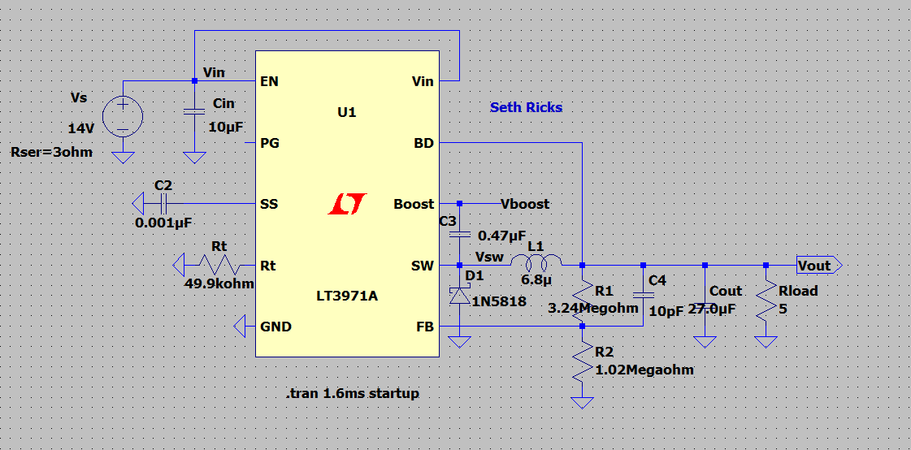
Figure 1: Voltage Regulator LTspice Circuit

Next, I will discuss the simulation of the voltage regulator circuit. Using the ‘.tran 1.6ms startup’ SPICE directive, we can view the circuit in the first 1.6ms during startup. This simulation can be seen in Figure 2 below. This plot has three traces: V(vin), V(vout), and I(Rload). The input voltage is seen in green, the output voltage in blue, and the load current in red. As can be seen in the figure, the input voltage spikes to 14V and then settles slightly, the output voltage rises gradually to the desired 5V, and the load current is maximized at 1A.
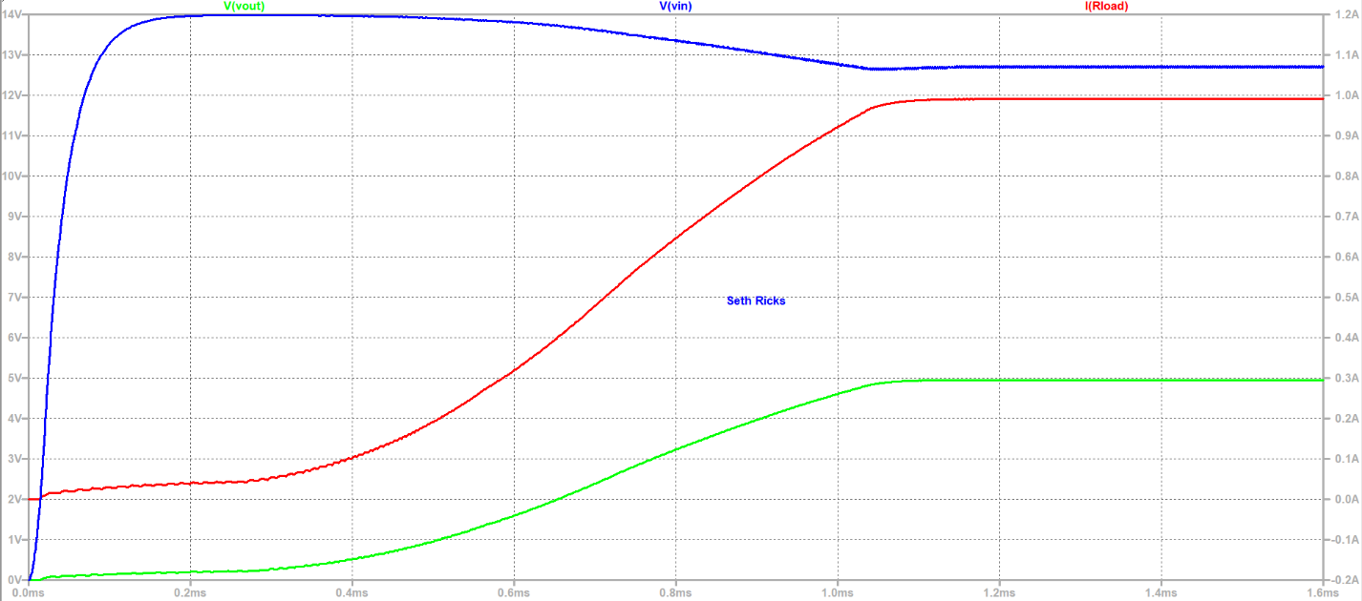
Figure 2: Voltage Regulator Startup Simulation
I have also generated an efficiency report, which shows the performance of the voltage regulator. Unlike a linear regulator, which can waste power and operate with low efficiency, a switching regulator maintains high efficiency by minimizing energy loss during voltage conversion. In this case, we were expecting an efficiency of 80 to 95%. The efficiency report can be seen in Figure 3 below. Notice, I have changed the input voltage to be a higher 18V, and the Rseries resistance to be 0$Ω$. The latter is to assume an ideal voltage source.
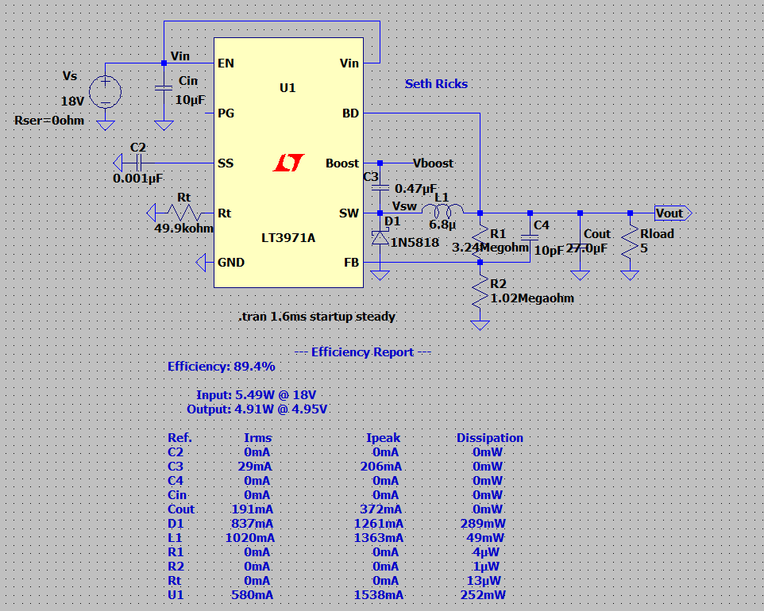
Figure 3: Switching Voltage Regulator Efficiency Report

From the efficiency report, I was able to extract the values given in Table 3 below. The input/output power and voltage, along with the efficiency percentage, were given in the report. Using these values and the equation $P=VI,$ I was also able to calculate the input and output currents.
P_{in} | V_{in} | I_{in} | P_{out} | V_{out} | I_{out} | % Efficiency
5.49W | 18V | 305mA | 4.91W | 4.95V | 991.9mA | 89.4%
Table 3: Input and Output Voltage, Current and Power Values of Step-Down Regulator.
Figure 4 is a simulation plot of the step-down voltage regulator at setup state. This means that it is safe to assume that the circuit has been active for a long time. There are four traces in this plot: V(vsw), V(vboost), V(vout), and I(L1). V(vsw) is the voltage at the switching node. V(vboost) is the higher voltage provided to charge the external capacitor, as discussed previously. The output voltage, V(vout), floats around the desired 5V, and the I(L1) current to the load is around 1A as discussed above.
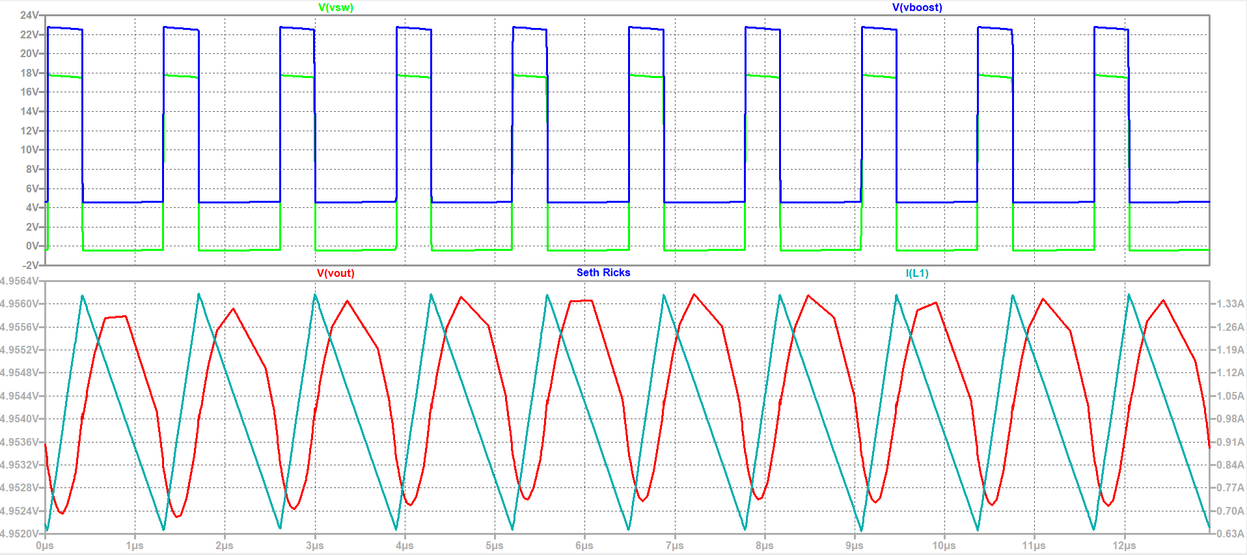
Figure 4: Steady-State Simulation Plot

In this report, I have discussed functions of the LT3971A IC, the switching frequency, the output voltage, the start-up simulation, the efficiency of the circuit, and the steady-state simulation. At an efficiency of 89.4%, this is a much more conservative circuit than a linear voltage regulator. The efficiency of a linear voltage regulator can be found using the equation: $100(V_{out}/V_{in}).$ In our case of an 18V input and a 5V input, the corresponding efficiency would be a miserable 27.8%. This is 61.6% worse than the switching regulator! In this project I have learned of the usefulness of the switching regulator, and plan to use it in the future in my projects and career.

